AUTONOMOUS LEGAL RESEARCHER AGENT

Course Name: Agentic AI

Institution Name: Medicaps University – Datagami Skill Based Course

Student Name(s) & Enrolment Number(s):
Sr no | Student Name | Enrolment Number
1. | Saransh Pillai | EN22CS301870
2. | Sandeep Rathore | EN22CS301861
3. | Shreya Kabra | EN22CS301929
4. | Shivanshi Shrivastava | EN22CS301915
5. | Shivangi Patidar | EN22CS301910

Group Name: Group 02D8
Project Number: AAI-37
Industry Mentor Name:
University Mentor Name: Prof. Pradeep Baniya
Academic Year: 2025-26

Problem Statement & Objectives

1. Problem Statement

Legal research is a structured and detail-oriented process that requires examination of statutes, case laws, amendments, notifications, and judicial interpretations published across multiple government and court platforms. Traditional manual legal research is time-consuming, repetitive, and error-prone due to fragmented information sources and the absence of intelligent consolidation mechanisms. Students and researchers often struggle to retrieve relevant legal material efficiently while maintaining contextual continuity across queries.

2. Project Objectives
The primary objectives of the project are:
- To design a controlled autonomous legal research system for academic use
- To automate planning and execution of legal research tasks
- To interpret natural language legal queries accurately
- To retrieve information from publicly accessible legal sources
- To maintain contextual memory for multi-turn interactions

3. Scope of the Project
The scope of this project is limited to an academic prototype of a legal research assistant. The system supports controlled autonomy, where planning and execution are automated within predefined tools and safety constraints. The project does not provide legal advice and does not access private or paid legal databases.

Proposed Solution
- Key features
- Natural language legal query handling
- Autonomous research planning
- Automated legal source discovery
- Content extraction and summarization
- Context-aware memory handling
- Web-based user interface

- Overall Architecture / Workflow
The Autonomous Legal Researcher Agent is designed using a modular, agent-based architecture. The workflow begins with a user submitting a legal query through the frontend interface. The backend initializes the agent controller, which coordinates planning, searching, scraping, summarization, and knowledge storage. Each module operates independently with clearly defined responsibilities, ensuring maintainability and scalability.

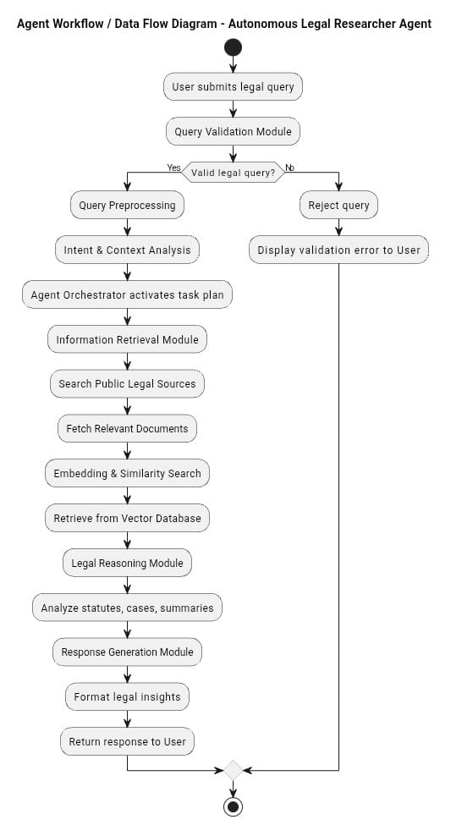

- Tools & Technologies Used
- Python (Core language)
- Streamlit (Frontend framework)
- LangChain (LLM orchestration)
- Google Gemini API (LLM for summarization)
- Selenium (Dynamic content handling)
- Chroma Vector Database (Semantic memory storage)

System Design Overview
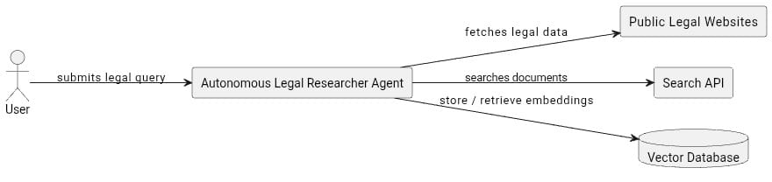
High-Level Design (HLD)
The system follows a client–server architecture and is divided into three logical layers:
Frontend Layer
Responsible for user interaction and visualization. It provides an interface for query submission and displays research results.
Backend Layer
Acts as the orchestration layer, managing API calls, workflow control, and communication between frontend and AI agents.
AI Agent Layer
Implements intelligent behavior including planning, searching, summarization, and memory management.
The backend is stateless to support scalability, while fallback planning mechanisms enhance reliability.

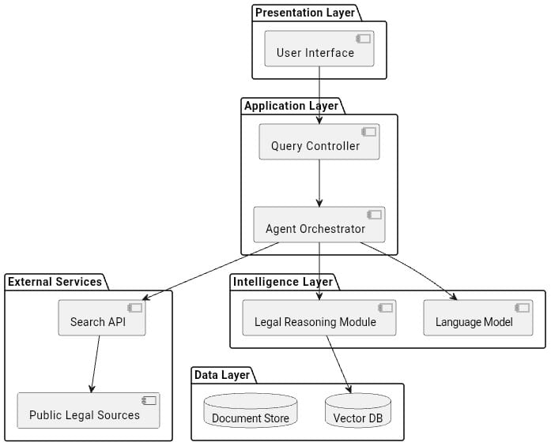

Architecture Data Flow
- User submits a legal query
- Frontend forwards query to backend
- Agent Controller initializes execution
- Planner generates research strategy
- Search Tool retrieves relevant URLs
- Scraper extracts legal text
- Knowledge Store saves context
- Final response is returned to the user

Low-Level Design (LLD)
Module 1: Agent Controller
Class: LegalResearchAgent
Responsibility: Acts as the central coordinator of the system. It manages execution flow and communication between modules.
Key Attributes:
- agent_name
- planner
- search_tool
- summarizer
- memory_store
Key Method:
run(query): Accepts user query, invokes planner, coordinates execution, and returns final response.

Module 2: Planner Module
Class: Planner
Method: create_plan(query)
Responsibilities:
- Analyzing user query
- Identifying legal domain
- Selecting appropriate sources
- Defining execution sequence
- Supporting strategy adaptation
The planner follows the single-responsibility principle and outputs a structured research plan.

Module 3: Search and Scraping Modules
SearchTool Class:
- Method: search(plan)
- Function: Queries trusted public legal sources and collects relevant URLs.
Scraper Class:
- Method: extract_text(url)

- Function: Extracts clean legal content by removing scripts and advertisements.

Module 4: Summarization and Knowledge Storage
Summarizer Class:

- Method: summarize(text)
- Uses LLM APIs to generate accurate and structured summaries.

KnowledgeStore Class:
- Methods: store(query, summary), retrieve(query)
- Maintains persistent memory using vector storage for semantic search.

Execution Flow (Detailed)
- User submits legal query
- Agent Controller initiates execution
- Planner generates strategy
- Search Tool retrieves URLs
- Scraper extracts content
- Summarizer processes legal text
- Knowledge Store saves context
- Final answer delivered to user
This represents a controlled autonomous execution pipeline.

Non-Functional Requirements
Performance :- Efficient planning and fast response times for academic usage.
Scalability :- Modular agent-based design allows future extension.
Reliability :- Fallback planning ensures continuity in case of partial failure.
Security :- No sensitive user data is stored; system accesses only public sources.

Results & Output
Screenshot snippets

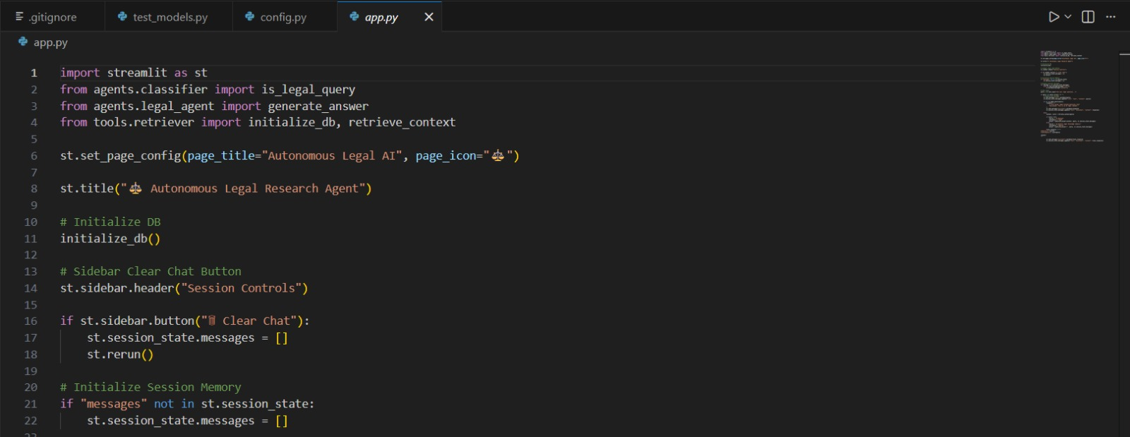

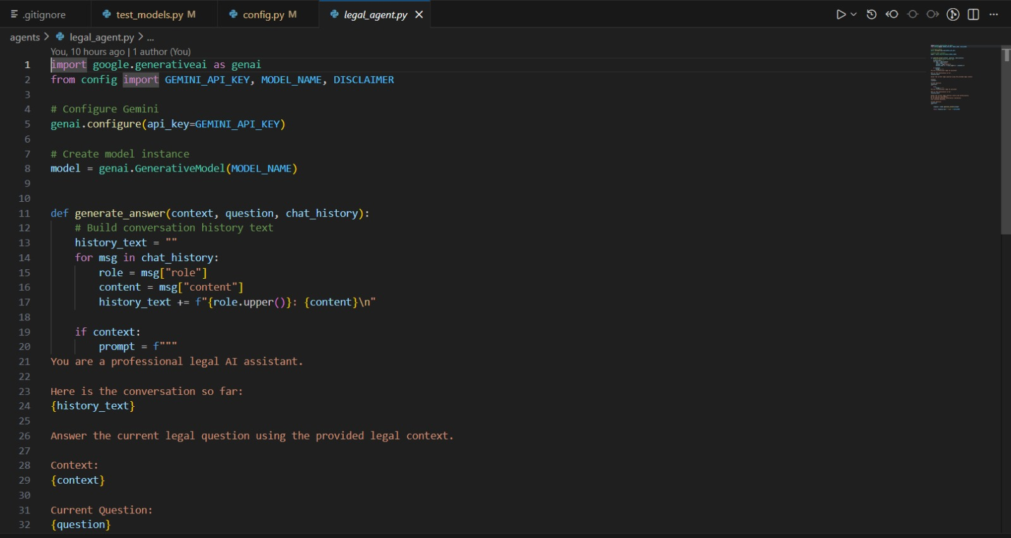

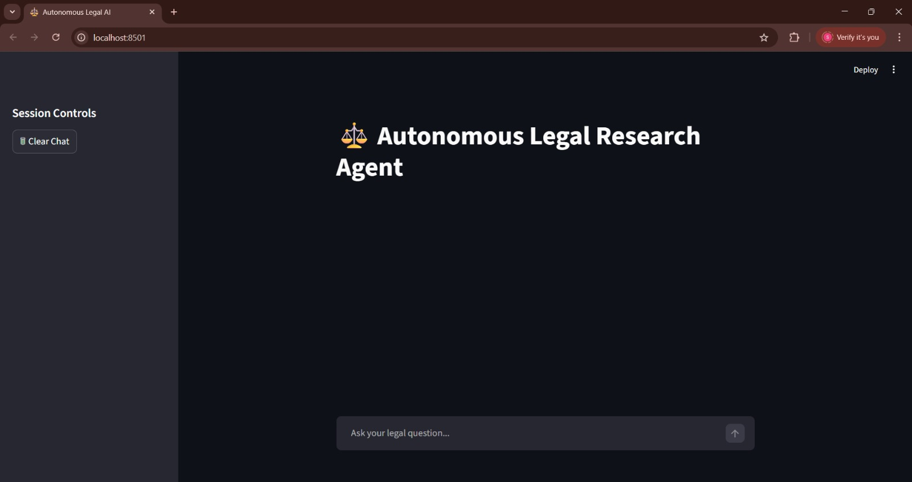

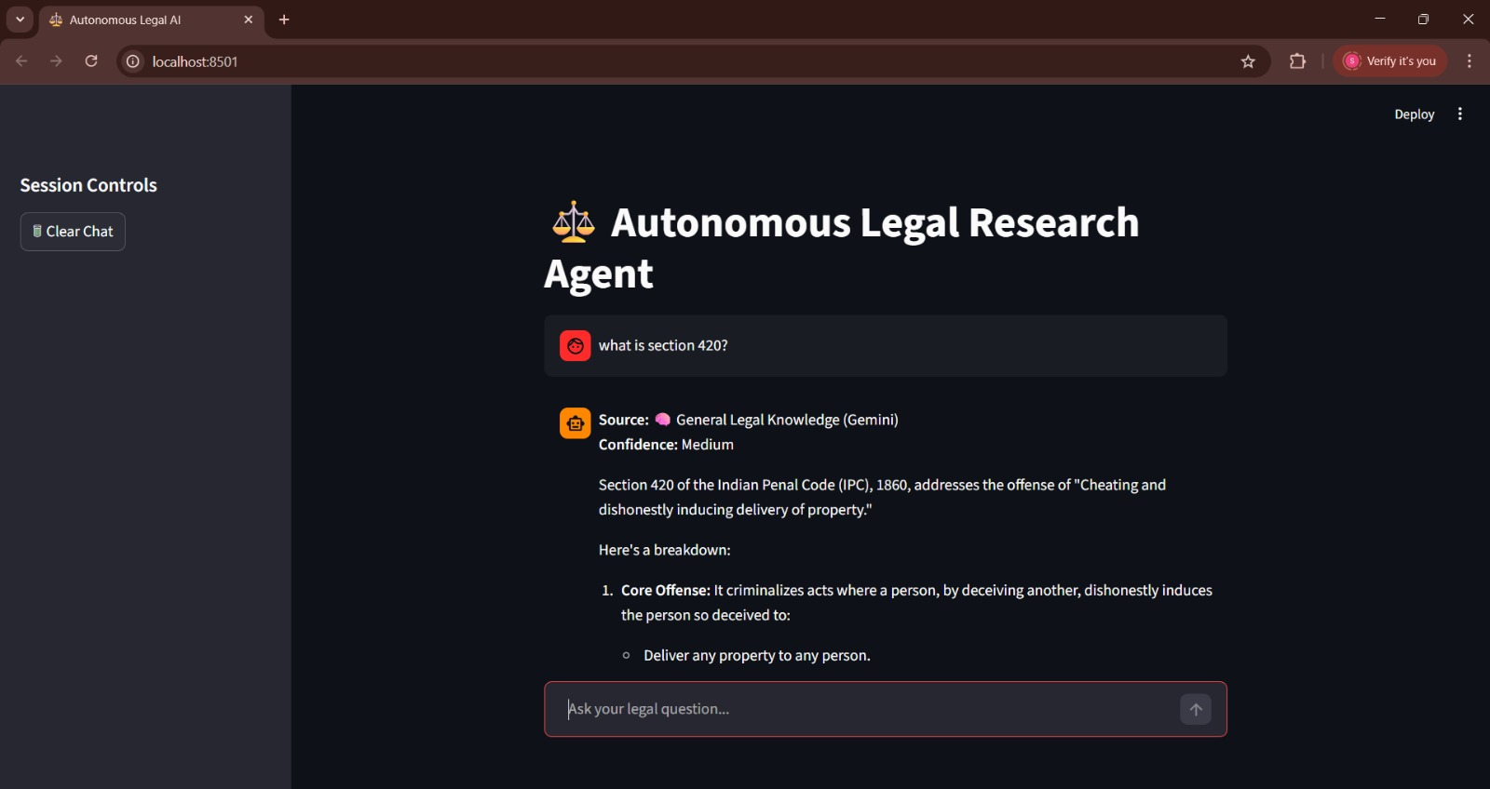

Key Outcome :-
- Reduced research time
- Improved consolidation of legal information
- Demonstrated agentic AI concepts

Limitations

Depends on public legal sources only

Accuracy limited by source availability

Not a substitute for professional legal advice

Conclusion
The Autonomous Legal Researcher Agent successfully demonstrates the application of agentic AI principles in automating legal research tasks. By combining modular architecture, controlled autonomy, and LLM-based summarization, the system achieves academic objectives while maintaining ethical and safety constraints.

Future Scope & Enhancements
- Integration with verified government APIs
- Advanced citation validation
- Multilingual legal research
- Enhanced semantic search capabilities

